Format Check

Definition
# Source: AI Source: Provided by: [Data Path: Persons Table -> ID Column: 1, Name_En Column: Motasem Essam] -> From: [Chatgpt (GPT‑5 Mini)] on [12/10/2025]
Format Check ensures that the data entered follows a predefined format or structure.
- It is used to prevent invalid data that does not conform to the expected type or pattern.
- Commonly applied to text fields, numbers, codes, dates, and emails.

Key idea:
# Source: AI Source: Provided by: [Data Path: Persons Table -> ID Column: 1, Name_En Column: Motasem Essam] -> From: [Chatgpt (GPT‑5 Mini)] on [12/10/2025]
It’s like checking that a phone number has exactly 10 digits or that an email contains “@” before accepting it.

Characteristics
# Source: AI Source: Provided by: [Data Path: Persons Table -> ID Column: 1, Name_En Column: Motasem Essam] -> From: [Chatgpt (GPT‑5 Mini)] on [12/10/2025]
- Validates the structure of data, not the actual value.
- Often used for text patterns, numeric patterns, date formats, and codes.
- Can be automated using regular expressions, database constraints, or software validation rules.
- Helps reduce errors at the point of entry.

Examples
# Source: AI Source: Provided by: [Data Path: Persons Table -> ID Column: 1, Name_En Column: Motasem Essam] -> From: [Chatgpt (GPT‑5 Mini)] on [12/10/2025]
- Phone Number Validation
- Expected format: 10 digits
- Valid: 0123456789 ✅
- Invalid: 123-456-789 ❌
- Email Validation
- Expected format: username@domain.com
- Valid: user@example.com ✅
- Invalid: userexample.com ❌
- Date Validation
- Expected format: DD/MM/YYYY
- Valid: 13/03/2026 ✅
- Invalid: 2026/03/13 ❌
- Postal Code Validation
- Expected format: 5-digit numeric code
- Valid: 12345 ✅
- Invalid: 12A45 ❌

Advantages
# Source: AI Source: Provided by: [Data Path: Persons Table -> ID Column: 1, Name_En Column: Motasem Essam] -> From: [Chatgpt (GPT‑5 Mini)] on [12/10/2025]
- Ensures data conforms to required patterns
- Reduces entry errors and invalid records
- Supports data consistency across the system
- Simplifies subsequent processing and analysis

Disadvantages
# Source: AI Source: Provided by: [Data Path: Persons Table -> ID Column: 1, Name_En Column: Motasem Essam] -> From: [Chatgpt (GPT‑5 Mini)] on [12/10/2025]
- Cannot detect logically incorrect data (e.g., age = 200 passes format but is invalid)
- May reject non-standard but valid data if rules are too strict
- Requires well-defined patterns for all data fields

Example Section
# Source: AI Source: Provided by: [Data Path: Persons Table -> ID Column: 1, Name_En Column: Motasem Essam] -> From: [Chatgpt (GPT‑5 Mini)] on [12/10/2025]
A school database requires student emails to follow the format name@school.com:
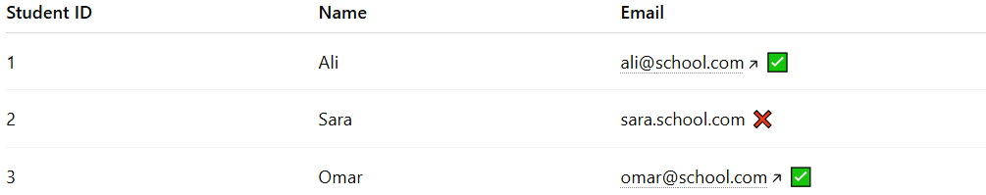
Student ID | Name | Email
1 | Ali | ali@school.com ✅
2 | Sara | sara.school.com ❌
3 | Omar | omar@school.com ✅
- The validation system rejects Sara’s email because it does not contain “@”.
- Only correctly formatted emails are stored for communication purposes.

